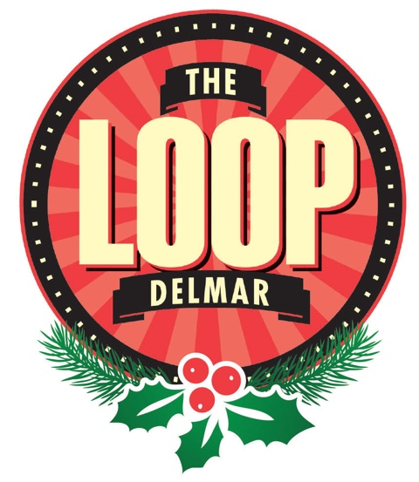
Media Contacts:
Lisa Anne Houdyshell
Serendipity Gallery
lisa@serendipity-gallery.com
314- 449- 6400

Jessica Bueler
The Loop Special Business District
visittheloop@gmail.com
314-938-8000

For Immediate Release:
Tuesday, November 1st, 2016

The Loop Special Business District Announces Holiday Happenings 2016:
All I Want For the Holidays is in the Delmar Loop

St. Louis, Missouri: The Loop, named "One of the 10 Great Streets in America" by the American Planning Association, is proud to announce our community’s annual Holiday events. Join us as local business owners celebrate the season with cheer, shopping, dining, and event merriment throughout November and December 2016.

Saturday, November 5 –Pre-Holiday Stuff Your Bag Sale.
Get some early holiday shopping in this weekend. Loop retailers have seasonal merchandise for sale and special pre-holiday promotions on gifts, decorations and gift cards. It’s never too soon to support local businesses and get some gifts checked off your list. The Loop has unique special offers for the whole family.

Saturday, November 26 – Small Business Saturday.
The Delmar Loop is home to over 100 locally owned restaurants, concert venues, galleries and boutiques. Come out this Small Business Saturday and enjoy shopping and dining while you show your support for our local entrepreneurs and artists.

Beginning December 2 - Enjoy Decorated Windows Throughout the holidays
Enjoy a holiday stroll with your family down the length of The Loop and enjoy the simple pleasure of our holiday window decorations. Students from Bertha Knox Gilkey Pamoja Prep. Academy at Cole under the supervision of Celeste Grayer will be assisting The Loop with some of the decorating. Windows displays will incorporate our theme “All I Want For The Holidays Is In The Loop”.

Friday, December 2 – 6:00 pm Tree Lighting Ceremony and Santa’s Arrival.
at Fitz’s Root Beer (6605 Delmar) for our annual tree lighting. The Duke of Delmar, Joe Edwards, will deliver Santa in retro style at 6 pm. Stick around for music by St. Louis Christmas Carols Association, chance encounters with other holiday characters, special musical guests, and more as we Light up The Loop for the holidays.

Sunday, December 4 – National Cookie Day.
It’s National Cookie Day! Collect a new cookie recipe and/or try out some of the great baked goods available in The Loop. Holiday characters will be strolling through The Loop from Noon to 4 pm. Feel like making something for the holidays? The Craft Alliance will host a craft event – stop by and make a candy cane mouse you can take home or trade for a cookie at a participating retailer.

Saturday, December 10 – 2nd Annual Great Gift Hunt.
Shoppers and diners will have the chance to “find” gift certificates from participating businesses! Each customer that makes a purchase in a participating business during the Great Gift Hunt will receive a holiday gift bag. The gift bag may contain candy or a gift certificate from that business or a gift certificate for our grand prize, The Loop Family Day Package (including everything you and your family need for a fun filled day in The Loop). Don’t forget to check out the Holiday Market in The Loop from 9 am to 1 pm.

Friday and Saturday, December 16 and 17 – National Ugly Holiday Sweater Days.
Breakout your ugly holiday sweaters and join the fun as we celebration National Ugly Holiday Sweater Day in The Loop. On Friday, December 16, we kick off the merriment with an Ugly Sweater Pub Crawl and Sweater Contest at The Eclipse Bar at the Moonrise Hotel starting at 8 pm and continue along The Loop visiting participating bars for signature drinks and specials. Our Ugly Sweater Reindeer will present the ugliest sweater winner with a night’s stay at the Moonrise Hotel. The fun continues Saturday, December 17 with family oriented ugly sweater fun. Pose with Santa or our Ugly Sweater Reindeer from noon to 4 pm. Don’t forget those ugly pet sweaters. Make our Ugly Sweater weekend a part of your annual El Monstero tradition (they’ll be at The Pageant on Dec. 16 and 17). We have lots of ugly sweater fun in store for everyone!

Saturday, December 24 – Show Me Chanukah Menorah Lighting.
Celebrate Hanukkah at 7:30 pm in the Market Plaza with the Fifth Annual Public Menorah Lighting in the Delmar Loop officiated by Rabbi Novak. Featuring live Klezmer Music by a student band, Free Hot Latkes and chocolate Gelt, Joyous Chasidic dancing... and more.

Wednesday, December 28 – Kwanzaa Celebration in the Delmar Loop.
Kwanzaa is a week-long holiday falling between December 26 and January 1 each year, culminating in a feast and gift-giving. Join us as we honor African culture and traditions on Wednesday, December 28 at 4 pm in the Market Plaza. Enjoy the Kinara Lighting Ceremony and a performance by students from Bertha Knox Gilkey Pamoja Prep. Academy at Cole.

For a full calendar and list of events please visit: http://visittheloop.com/holidays2016/
If you have additional questions, please feel free to contact us at the numbers listed above
###

